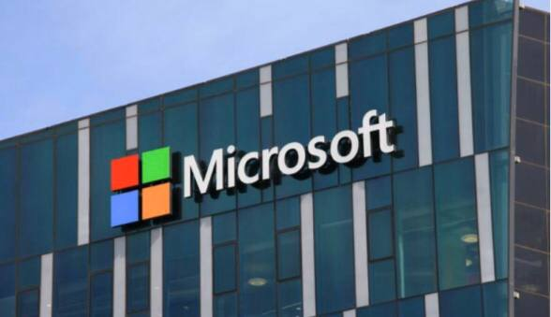Microsoft is born

Inspired by the January cover of Popular Electronics magazine, friends Bill Gates and Paul Allen Started Microsoft-Sometimes Micro-Soft, for microprocessors and software- to develop software for the Altair 8800, an early personal computer.

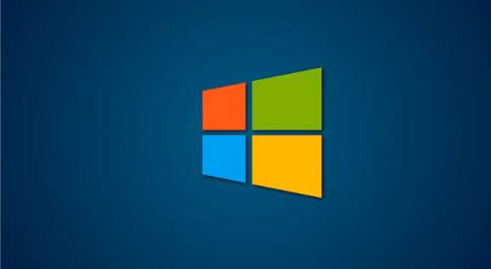

In 1980, the pair struck a deal to provide the operating system for IBM’s first personal computer. Microsoft released Windows in 1985, a year before moving its headquarters to Redmond, Washington by the late 1980s, Microsoft was the word ’s largest personal-computer software company.